**Year 3-4 week ending 21.10.22**

English: We have been writing our non-chronological report in English this week. We have successfully used our facts to explain why we should recycle more and used alliteration to explain our arguments in greater detail

We have decided that we must act now to save our seas and marine life.

L.S Lowry has been our focus in art and DT this week. We have investigated who he was, what pictures he drew and the impact they have had on our knowledge of social history at the time.

We have been drawing our own match stalk figures and examined the poses they were drawn in. We have also examined the colours that Lowry used in his paintings and why his pictures were not viewed favourably at the time.

Finally, we are using this knowledge to make our own Lowry pen pot!

Great performance all around this week. Column addition was a challenge at the beginning of the week but we have made good progress. Taking time to form our numbers correctly and lay out our work neatly has definitely paid off!

We all enjoyed our spooky afternoon! Everyone had a brilliant time and we all looked amazing

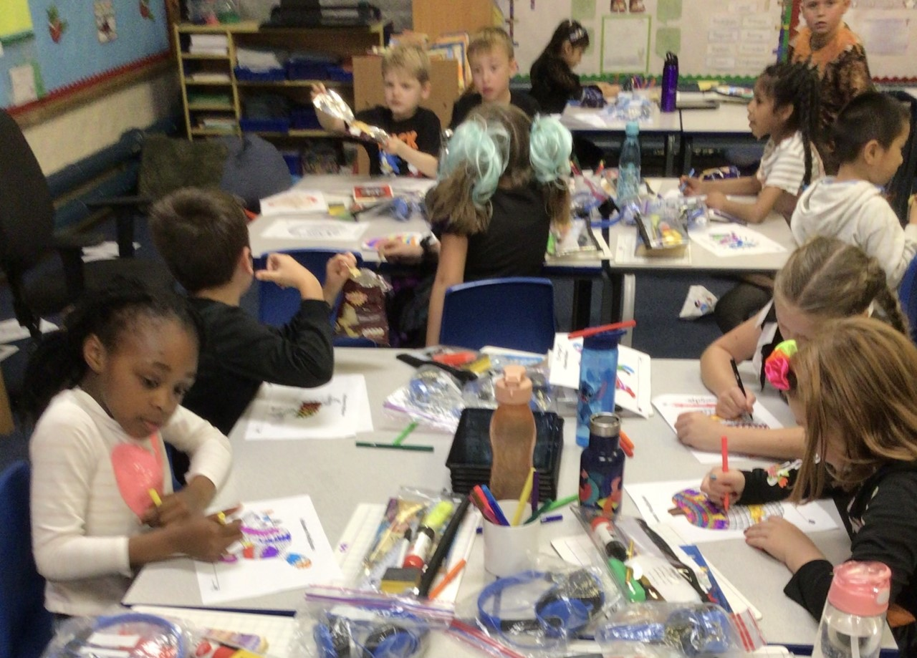

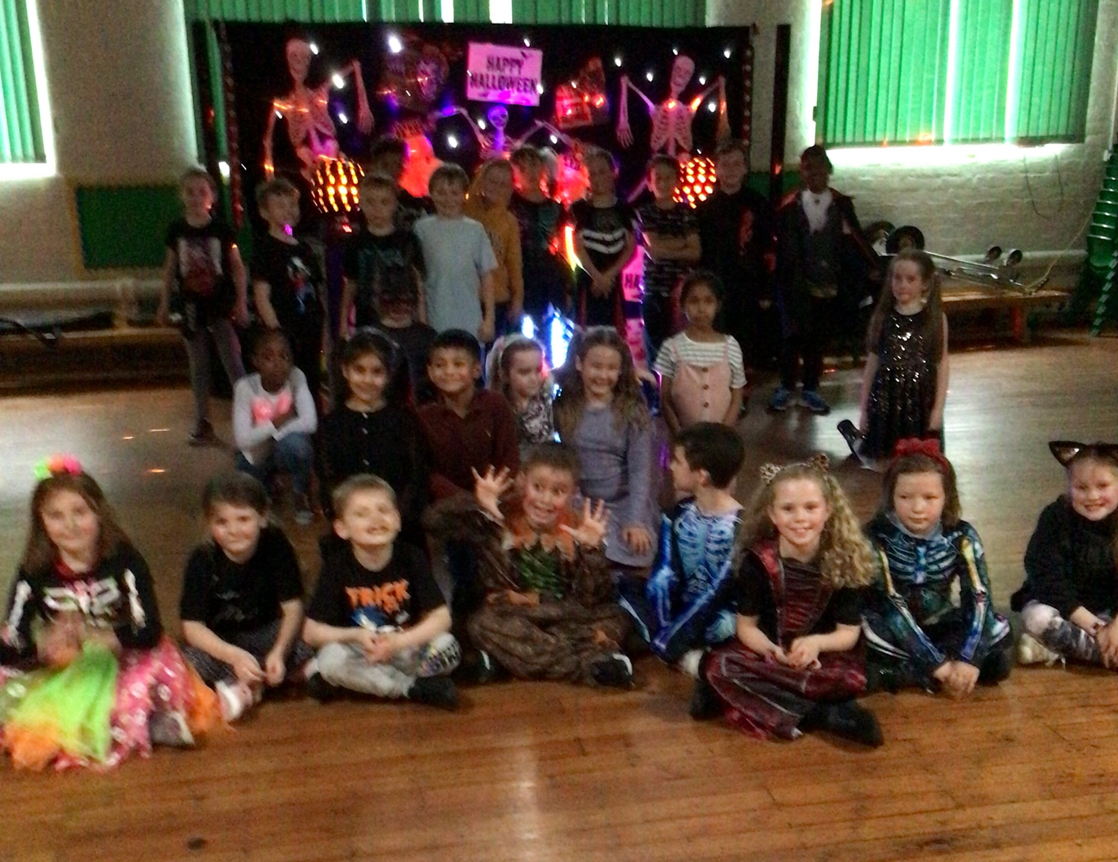

Movie afternoon and popcorn was our reward this week for a full cube jar.

Well done to everyone – let’s see how long it takes to fill it again.

**Have a happy and restful half term.**